Interventional Pulmonology
Tunneled Pleural Catheter: Patient Information
A tunneled pleural catheter (TPC) often referred to as a PleurXTM catheter can be inserted during an outpatient appointment for drainage of abnormal accumulation of fluid around your lungs also called a pleural effusion.

REASONS FOR A TPC:
The TPC drainage system allows for a flexible drainage schedule outside of the hospital. As fluid accumulates it can be easily drained before symptoms (i.e. shortness of breath, cough) become too uncomfortable. The drainage catheter is easy to manage. When you need to drain fluid you connect the end of the TPC to the drainage line attached to a collection bottle as demonstrated in Image 1. Typically a visting nurse will come to your home and assist with drainage.

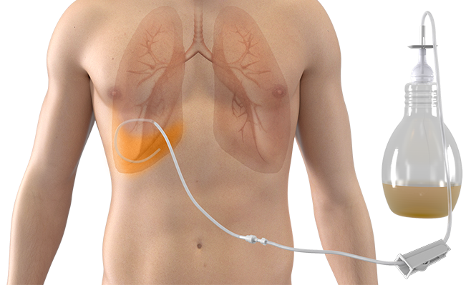
PREPARATION:
Most medications are safe to continue on the day of the procedure. Any use of blood-thinners, such as Warfarin, Lovenox, Plavix, etc., should be discussed with your doctor or nurse a week before the procedure in case it needs to be stopped. The majority of the time you can eat and drink as you wish on the day of the procedure. If the catheter is being placed in the operating room you must stop eating and drinking at midnight the night before.

Image 1: PleurXTM. Courtesy and © Becton, Dickinson and Company
Reprinted with permission

PROCEDURE:
The procedure may take place in our outpatient clinic or in the operating room. A TPC can be safely and comfortably placed with numbing medication into the skin similar to medication provided while at the dentist. If done in conjunction with another procedure, anesthesia may be required, and the catheter placement will be placed in the operating room. During the procedure the doctor or nurse practitioner will make two small (less than 2 cm) incisions at different places between your ribs. The catheter will exit the skin at the site of one of the incisions and stitches will be used to close both cuts. The site where the catheter exits should be covered with a dressing when not being used for drainage.

COMPLICATIONS:

Related to catheter insertion-
- Minor pain or discomfort at incision/insertion site. You can take Tylenol as needed for pain.
- Bleeding occurs infrequently. If bleeding is noted through the bandage please apply pressure with your hand until it stops.
- Infection occurs infrequently. The procedure is performed under sterile conditions and an anti-septic is used on the skin prior to making the incision to minimize the risk for infection.
- Pneumothorax (lung collapse) occurs infrequently. A chest x-ray will be performed at the end of the procedure to identify any complications.

Related to catheter drainage-
- Pneumothorax (lung collapse) is rare.
- Pulmonary edema (water in the lungs) is rare and most often related to the speed of drainage.
- Low blood pressure.
- Infection risk is approximated to be 5%.
- Pain.

FOLLOWING THE PROCEDURE:
Depending on your doctor’s recommendations you may be discharged home or you may need to stay in the hospital for observation and treatment. If discharged home on the same day you must have a ride after the procedure due to the pain and sedation medications given to you if the procedure was completed in the operating room. Once at home, the drain is usually managed by a visiting nurse. Typically, you are seen in follow up in two weeks following the catheter placement or if there are concerns about the catheter drainage or insertion site.

Upon leaving the hospital you will be given instructions as to how frequently to drain the catheter. Usually it takes approximately 5 to 15 minutes to drain and should be completed using clean technique with alcohol or Chlorhexidine wipes to clean the end of the catheter. While the catheter is not being used it should be covered with gauze and an occlusive dressing. Do not drain more than 1000mL of fluid from your chest at any one time. Please contact or have your visiting nurse service (VNS) contact our office if three consecutive drainages are less than 50mL for consideration of removal or for troubleshooting a possible clogged TPC.

Please seek medical assistance immediately if you have the following:
- Increasing chest pain or shortness of breath.
- Fever (>100.4F), pain at the insertion site or pus around the catheter insertion site as it could be a sign of infection.

If you have any questions or concerns, please call our office at 617-632-8252.

