Interventional Pulmonology
Pleurodesis: Patient Information
YOUR LUNGS AND HOW THEY WORK:
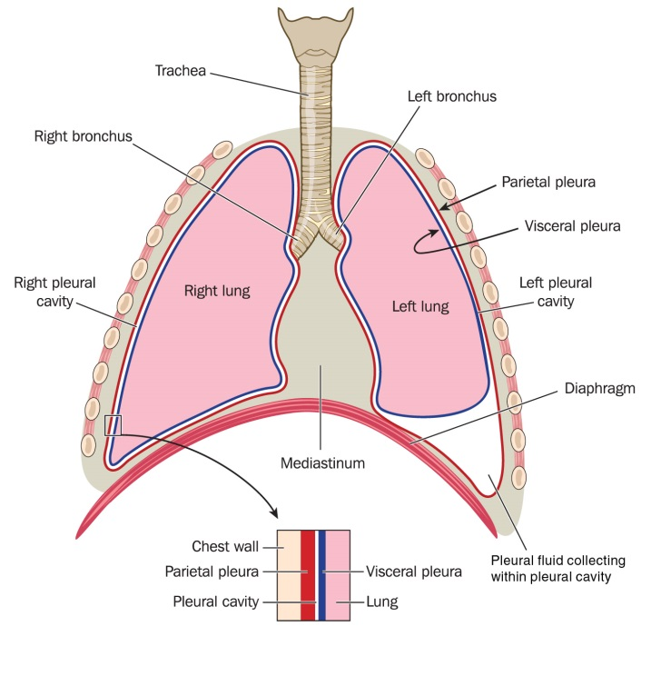
When you breathe in through your nose and mouth, air passes down your windpipe (trachea). This then divides into two tubes (bronchi), which lead to your left and right lungs. The lungs are wrapped in two layers of tissued called the pleura. The outer layer (parietal pleura) lines the chest wall and the inner layer (viseral pleura) covers the lung itself (Image 1). A thin film of fluid separates the two pleural layers and enables them to slide over each other as you breathe in and out.

PLEURAL EFFUSION:
A pleural effusion is a collection of excess fluid in the space between the two layers of pleura. This can compress the lung and may cause shortness of breath. A pleural effusion is usually the result of damage to the pleura and may be due to trauma, surgery, infection, cancer or some other disease. Treatment involves draining the excess fluid from the pleural space with a chest tube/drain.
Image 1: Lung Anatomy. Blamb/Shutterstock.com
The drain will be inserted through the chest wall into the space between the two layers of pleura. This allows for the excess fluid to drain and usually stays in place until the lung has re-expanded to fill its usual space. A chest x-ray or ultrasound will be performed to evaluate for adequate drainage and lung expansion.

PROCEDURE:
Pleurodesis causes the two layers of pleura to become irritated and inflamed so that when the lung re-expands they stick together and the lung is anchored to the chest wall. This should prevent the fluid from returning. The procedure is most successful if the pleural space is kept completely dry.
Pleurodesis is performed by injecting a talc solution into the pleural space through the chest drain or by directly spraying talc during a pleuroscopy. The solution will usually be made of sterile talc, normal saline (salt water) and a numbing medication (lidocaine). The chest drain will then be clamped for 2-4 hours. Occasionally, fluid may drain from the pleural space for days after the pleurodesis and in that case a drain will be left in place until it stops.

FOLLOWING THE PROCEDURE:
The first 24 hours following the procedure you may experience some chest pain, this can range in severity from mild to severe. Some patients require hospitalization for pain management while other can be sent home with a short course of pain medication. You may take Tylenol for pain management. It is recommended that you avoid non-steroidal anti-inflammatory medication (NSIADS) like Ibuprofen.
- You may go back to your usual activities 24-48 hours after chest tube removal
- You may eat and drink whatever you would like following the procedure
- You will have a small bandage over the chest tube site that will need to remain dry. This should stay on for 48-72 hours after chest tube removal.
- If you experience bleeding or drainage from the site hold pressure with a clean washcloth for 5 full minutes or until the bleeding stops. If it does not stop please call the Chest Disease Center.
Although rare, you should seek immediate medical attention if any of the following occur:
- Severe chest pain or severe shortness of breath, call 911
- Worsening shortness of breath, coughing up blood, chest or back pain, redness or swelling at the site, bleeding that does not stop with pressure or if you have a temperature of >101 please go to the closest emergency department.
If you have any questions or concerns, please call our office at 617-632-8252.

