Interventional Pulmonology
Flexible Bronchoscopy: Patient Information
Flexible bronchoscopy [brong-kos-kuh-pee] is a procedure that allows a doctor to examine the breathing passages (airways) of the lungs. A bronchoscope is a thin flexible tube equipped with a light and camera allowing visualization of the airways often displayed on a video screen (Image 1).
REASONS FOR BRONCHOSCOPY
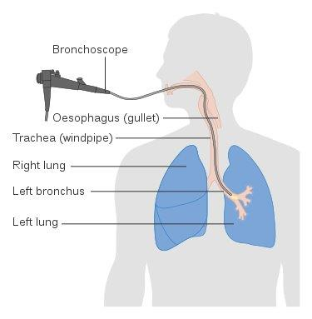
Flexible bronchoscopy can be either diagnostic to find out more about a possible problem or therapeutic to try to treat an existing problem. Often broncoscopies are performed to diagnose unexplained symptoms including persistent cough, coughing up blood, wheezing, hoarseness, noisy breathing or shortness of breath. It may also be done to identify a cause of narrowing or obstruction of the airway identified on imaging studies such as persistent lung collapse (atelectasis). If possible, the clinician removes the cause of the collapse to open the airways. In most cases, fluid samples or a biopsy are obtained to look for signs of infections, cancer, or inflammation.
Image 1: Bronchoscopy. Courtesy of Cancer Research UK

PREPARATION:
Do not eat or drink anything after midnight the night before your procedure. However, you may still take your prescribed morning medications with a small amount of water. Any use of blood-thinners, such as Warfarin, Lovenox, Plavix, etc., should be discussed with your doctor or nurse a week before the procedure. Taking these medications increases your bleeding risk and may prevent us from doing the procedure if not stopped. If you are taking medications for diabetes, please do not take them the day of the procedure, but bring them with you to the hospital.
The procedure takes approximately one hour and is done in the operating room. You will receive deep sedation or anesthesia and you must have a ride home. Rarely, you may need to be admitted after the procedure for monitoring purposes.
PROCEDURE:
You will be registered and prepared for the procedure by one of our pre-op nurses. When the procedure team, room and equipment are ready you will be wheeled into the operating room on a stretcher. You will be given oxygen throughout the procedure using a nasal cannula or a mask and we will monitor your oxygen levels. In some cases, we will deliver oxygen through a tube directly into your trachea. You will be given a sedative and pain medication through an IV to make the procedure more comfortable. The back of your throat will be treated with a numbing spray; this prevents coughing and gagging during the procedure.

The bronchoscope is placed in the nose or the mouth and advanced slowly down the back of the throat, through the vocal cords and into the airways. You may be asked to take deep breaths prior to being completely asleep to identify areas of airway collapse. Some people have an urge to cough or feel a sensation of not being able to catch their breath. If there is significant discomfort additional medication will be given. Once the airway inspection has been completed your doctor will proceed to take mucus samples, biopsies or complete any needed intervention. Upon completion of the bronchoscopy the bronchoscope is removed and you will be woken up.

COMPLICATIONS:
Bronchoscopy is a safe and effective way to evaluate your airway and lungs and in most cases performed without complications. Most complications that occur are minor and resolve on their own or are easily treated. Potential complications include:
- Throat pain is the most common complaint following bronchoscopy. This will resolve with time and you may take Acetaminophen (Tylenol) as directed on the bottle.
- Bleeding can occur if a biopsy is taken during the procedure. It is usually minor and stops without treatment. Rarely, bleeding can lead to severe breathing problems or need surgical intervention.
- Fever is relatively common in the first 24 hours after the bronchoscopy and is not always a sign of infection. If you have a fever (>100.4F) more than 24 hours after the procedure please call the Chest Disease Center.
- Lung collapse (pneumothorax) is a rare complication with this procedure. A pneumothorax is more likely to occur if a biopsy is taken during the procedure and if the lung is significantly inflamed or diseased. It may require a small tube to be placed between your ribs and admission to the hospital for a couple of days.

FOLLOWING THE PROCEDURE:
You will be transferred to the recovery area and you will be monitored for two or three hours and a chest x-ray will be obtained. If discharged home on the same day you must have a ride home after the procedure. You may not drive after the procedure due to the medications given to you during the bronchoscopy. The results will be sent to the doctor who referred you, your primary care physician and/or discussed at your follow-up appointment.

- You will receive a call from our office with the date and time for a follow-up appointment.
- Biopsy results take 7-10 days and will be discussed during your follow-up visit unless other arrangements have been made.
- Please seek immediate medical attention with increasing chest pain or shortness of breath or if you cough up more than a tablespoon of blood.

If you have any questions or concerns, please call our office at 617-632-8252.

