Interventional Pulmonology
Tracheostomy: Patient Information
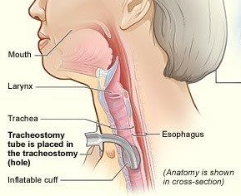
A tracheostomy is an opening surgically created through the front of the neck to allow direct access to the windpipe (Image 1). This can be done at the bedside with administration of pain and sedation medication with close monitoring or in an operating room under general anesthesia. A tube (Image 2) is usually placed through this opening to provide a safe, secure airway and to remove secretions from the lungs. Breathing is primarily done through the tracheostomy tube rather than through the nose and mouth.

REASONS FOR TRACHEOSTOMY:
A tracheostomy is usually done for one of three reasons.
- Deliver oxygen to the lungs
- Need for breathing support by mechanical ventilation
- Diaphragm dysfunction
- Long-term unconsciousness or coma
- Disorders in the brain which affecting breathing such as central sleep apnea
- Spinal cord injury or neuromuscular
diseases paralyzing or weakening chest
Image 1: Tracheostomy tube and anatomy.
Courtesy of National Heart Lung and Blood Institute
muscles and diaphragm
- To suction secretions from the airway
- Weak cough
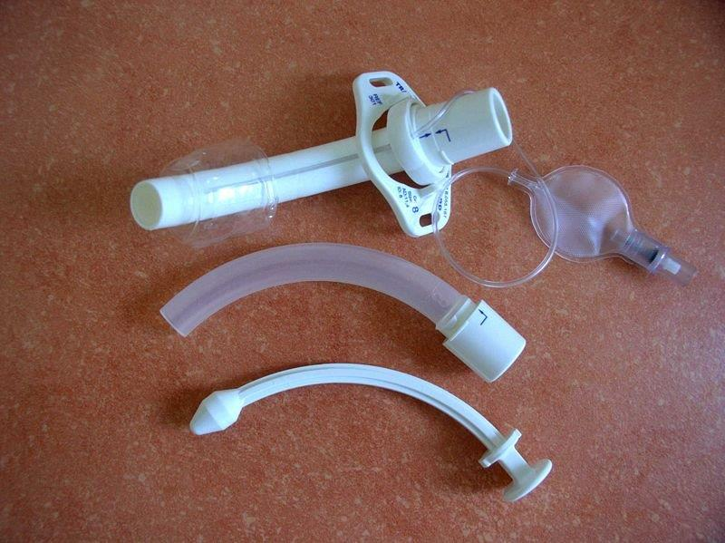
- To bypass an blocked upper airway
- Obstruction of the airway related to tumors, infection, vocal cord paralysis or an object
- Severe obstructive sleep apnea
- Injury to the voice box or mouth
- Facial surgery and facial burns
- Anaphylaxis (severe allergic reaction) with airway swelling
Image 2: Tracheostomy tube (top), inner cannula (middle), obturator (lower). Courtesy of Creative Commons

COMPLICATIONS:
As with any surgery, there are some risks associated with the creation of a tracheostomy. Although uncommon, they can be life-threatening.
Early Complications (during or soon after the procedure) include:
- Bleeding.
- Lung collapse (pneumothorax).
- Air trapped in the deeper layers of the chest (pneumomediastinum).
- Air trapped in the skin around the tracheostomy (subcutaneous emphysema)
- Damage to the swallowing tube (esophagus).
- Injury to the nerve that moves the vocal cords which create your voice (recurrent laryngeal nerve).
- Difficulty breathing due to blockage of the tracheostomy tube with blood clots, mucus or pressure of the airway walls. This can be prevented by suctioning, humidifying the air and selecting the appropriate tracheostomy tube.
Late Complications (while the tracheostomy tube is in place) include:
- Accidental removal of the tracheostomy tube (decannulation).
- Infection in the trachea and/or around the tracheostomy tube.
- Thinning and collapse of the trachea from the tube rubbing against it (tracheomalacia).
- Development of a small connection from the windpipe to the esophagus (tracheoesphageal fistula).
- Development of a small connection from the windpipe to the blood vessels around the windpipe which can result in bleeding.
- Development of scar (granulation) tissue.
- Narrowing of the airway (stenosis).
- If the tracheostomy tube is removed the opening may not close on its own requiring surgical closure.

Keeping your tracheostomy site clean with good tracheostomy tube care and regular examination of the airway should minimize the occurrence of any of these complications.

If you have any questions or concerns, please call our office at 617-632-8252.

