Interventional Pulmonology
T-Tubes: Patient Information
The Montgomery® Safe-T-Tubes (Image 1) are silicone tubes that were designed to maintain access to the airway and to provide support to an obstructed or narrowed windpipe (trachea). They have a “T” form with one horizontal external limb and an internal vertical limb. The tube is also supplied with a plug (cap) attached to the external limb. They serve as a stent (an expandable tube inserted to open a narrow area of the windpipe) and a tracheostomy (surgical access to the trachea) as seen in Image 2.

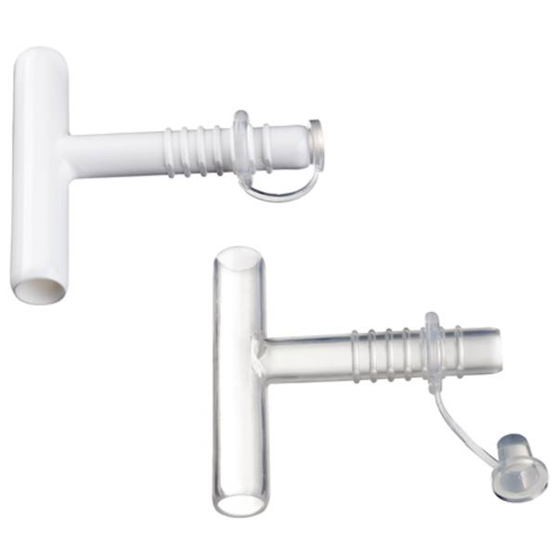
REASONS FOR T-TUBES:
T-tubes can be placed in patients airway for benign (non-cancerous) or malignant diseases in patient who are not good surgical candidates or patients who have not had a successful surgical procedure. For example, they can be used when patients are having diffuclty breathing or clearing secretions related to a blockage in their windpipe. A T-tube can also be used to open an airway when narrowed by scaring in the windpipe or compression from a mass outside of the trachea.

Image 1: Standard Safe-T-Tube TM.
Photo courtesy of Boston Medical Products

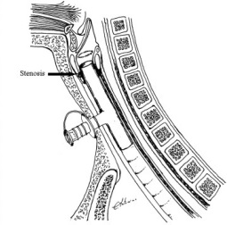

ADVANTAGES:
T-tubes allow uninterrupted flow of air into the lungs while providing support to the windpipe. With a T-tube in place patients can breathe and speak normally through their mouth. They are typically well tolerated by patients and can be kept in place for many years. For individuals who have large amounts of phlegm and have difficulty clearing secretions the T-tube can easily be uncapped and suctioned to help keep the airway clear of mucus.
Image 2: Neck anatomy with T-tube in place.
Photo courtesy of US National Library of Medicine.

PROCEDURE:
Placement of a T-tube is performed in the operating room under general anesthesia. The procedure is approximately 1 hour and patients can typically go home the same day.

COMPLICATIONS:
Complications from T-tubes are rare and death has never been reported as a direct complication of the procedure. However, all procedures carry a risk for complication.

Early complications: Migration requiring removal and reinsertion of the T-tube, air trapped in the skin around the tracheostomy (subcutaneous emphysema), and bleeding which is typically easily controlled.
Late complications: Mucus plugging or buildup of airway secretions, infection, granulation tissue or buildup of scar tissue around or at either end of the T-tube.
HOME CARE:
The T-tube should remain capped at all times to allow the patient to speak normally. Additionally, keeping the T-tube open promotes dryness of the airway which in turn makes it difficult to cough up secretions.
Instructions provided below for general care of a T-tube. These are often modified depending on the patient’s symptoms.
- With an eye dropper, place 1-2 teaspoons of normal saline (0.9% Sodium Chloride) into the T-tube every 4 hours and suction as needed. Some patients may not produce a lot of secretions so this step may not be necessary.
- Clean the inside of the external limb with a Q-tip soaked in a ½ hydrogen peroxide and ½ normal saline mixture twice a day.
- Clean the skin around the tube with surgical soap and water two times a day. Remove any crust.
- If you have any trouble breathing:
  - Uncap the external limb
  - Check for air movement by placing the palm of your hand over the opening of the external limb.
  - Signs that the T-tube is clogged include noise from the tube, difficulty speaking, or excessive cough
  - If ongoing difficulty breathing clean and suction the tube
  - For persistent symptoms after suctioning contact your doctor for further instructions or seek immediate medical attention by calling 911.
- In case of an emergency or the tube becomes completely obstructed a healthcare provider may need to remove the tube.
If you have any questions or concerns, please call our office at 617-632-8252.

